Hi Nathan
I had a look through and attempted to answer some of the questions.
Just to let you know I sell mostly fleece beanbags and a very small percentage of lycra beanbag.
Lycra beanbags are 20 euro more. I sell weighted blankets and lap pads.
I normally don’t sell to the domestic marketplace.
Most orders come from OT recommendations and school visits
But the OTs advise the clients that visit them and they then purchase from me. So they have heard about the product already.

Question 1
I have included photos below. I know I don’t have a great variety. See what you think.
I am not crazy about my personal photo being up on the website. I’ll think about that for now.
In the shop page on my website there are photos of a snake and lap pad. If they could be transferred over including their description, please
Question 2
XXXL beanbag price okay 425 euro
The colour photo display is good for now.

Question 3
Mini beanbags and sm beanbag. Yes,they are discontinued

Question 4
Shopping cart: I would like a shopping cart that is more fluid than what I have. Most people I think don’t use PayPal. So, thinking of stripe possibly, pay as you go model. Only pay a percentage when you have a sale, if that’s correct? … Is that something you know about? is there a lot involved in setting it up?

Question 5
- Returns and cancellations: In the over twenty years they has not been any returns. A couple of times something needed correcting which I gladly covered.
- So returns and cancellations are covered and there is probably a proper way to say that.
- Delivery outside of Ireland. Not at the moment
- I went through the whole CE process in 2017 where I sent my fabrics to the UK to be examined and in return I received a CE certification, the one on the website
- Care and washing of beanbags and weighted blankets below or could be shortened
Testamonials
There is a long list of testimonials under Testimonials on the web page

Phone and email on every page is good.

How to Order
Online or cash on delivery bank transfer Revolut
Free delivery cork city
10/15 euro currier.
 logo

Sensory Beanbags that help children settle
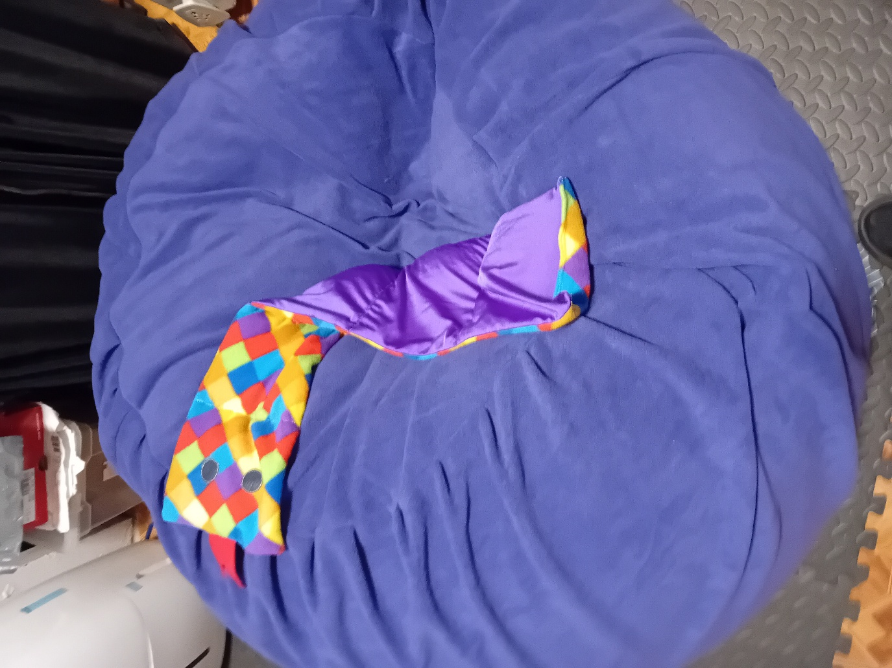photo
Made for body feedback not just sitting on
Designed by Julie Hannon
Manufactured for maximum movement and sensory needs not just for sitting on
Rough and tumble
Wrapping up or around itself, pushing against and climbing onto and back out .
Running into from a distance. Jumping from a trampoline or swing, rolling around and underneath for deep pessure

Not a pillow.

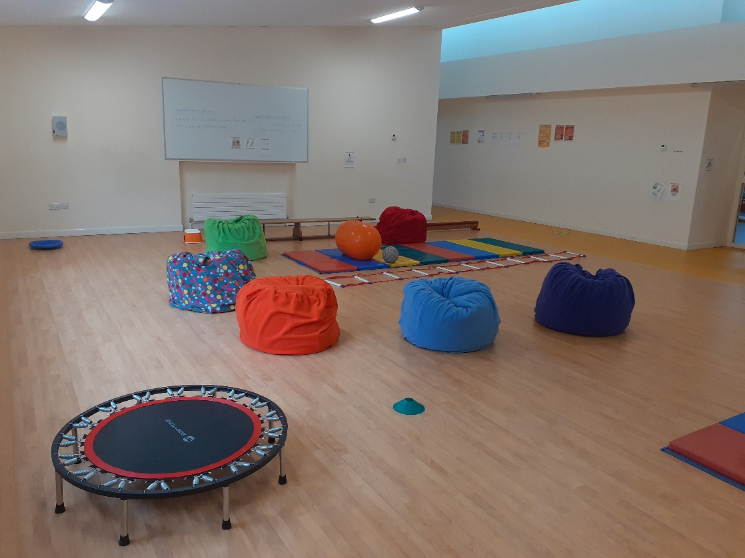
Douglas Boys school

A clinically designed tool for sensory regulation
Engineered through hundreds of hours of design to support special needs children in classes, therapy spaces and home
School and classroom approved
OT recommended design
Targeted Sensory input where standard cushions fail

Fleece and lining that survives real life 15-year guarantee
Fleece at the highest quality
Inner Lining at the highest quality
Haven’t had a parent return with any rip or breakage in several years

Hand made Cork
Not mass produced
Fabrics sizes and weights can be matched to each child

Care and washing
The cover is easily removed for washing

Fleece beanbags are the biggest seller
Showing Comparision below between fleece and lycra

Feature High-stretch lycra Lounger Limited Stretch Fleece

Best used for Sinking in, lying down, Standing jumps, firm resistance
Gentle wiggling, active sitting active sitting, wiggling
Yields to every stretch and turn

Sensory Benefit Continuous contouring High-impact deep pressure,
Hug and movement absorption, diving, head buts
Fabric Feel Cold Ultra-flexible Warm cosy supportive, animal
Slippery Furry
Watery Earthy

Note: I put this comparison in and then I saw it described another way further down in your design. Maybe two descriptions are good, not sure….
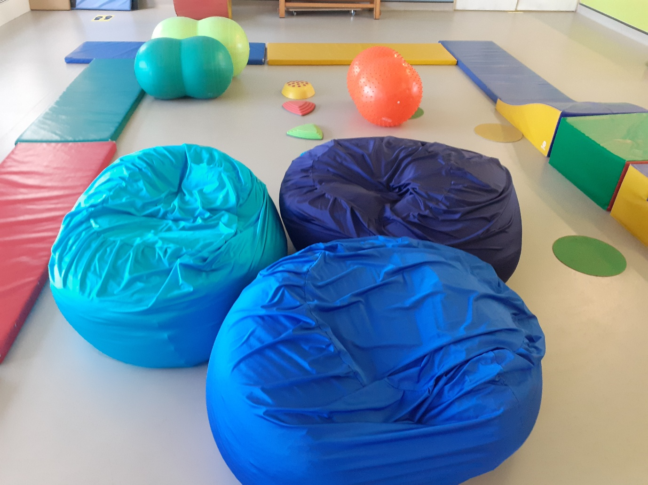

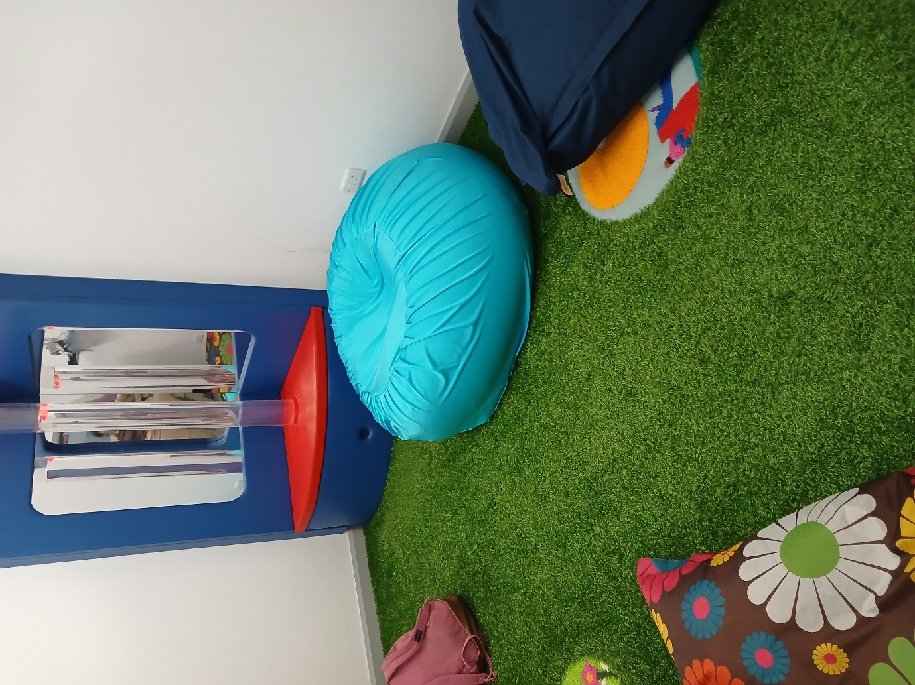

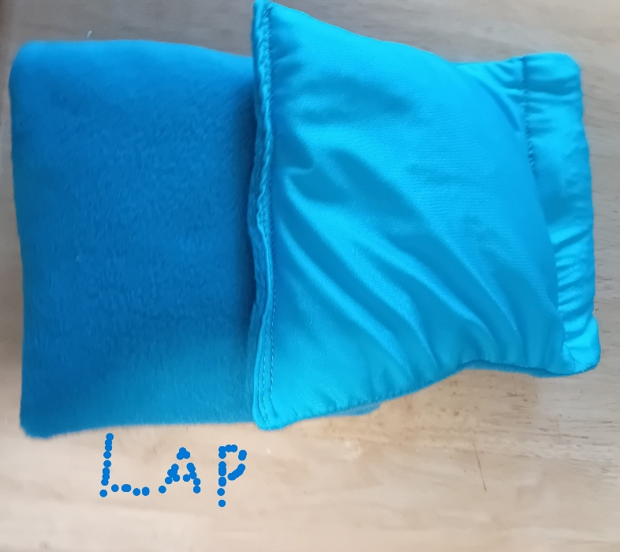
4lb lap Lycra/fleece - 15cm x 90cm
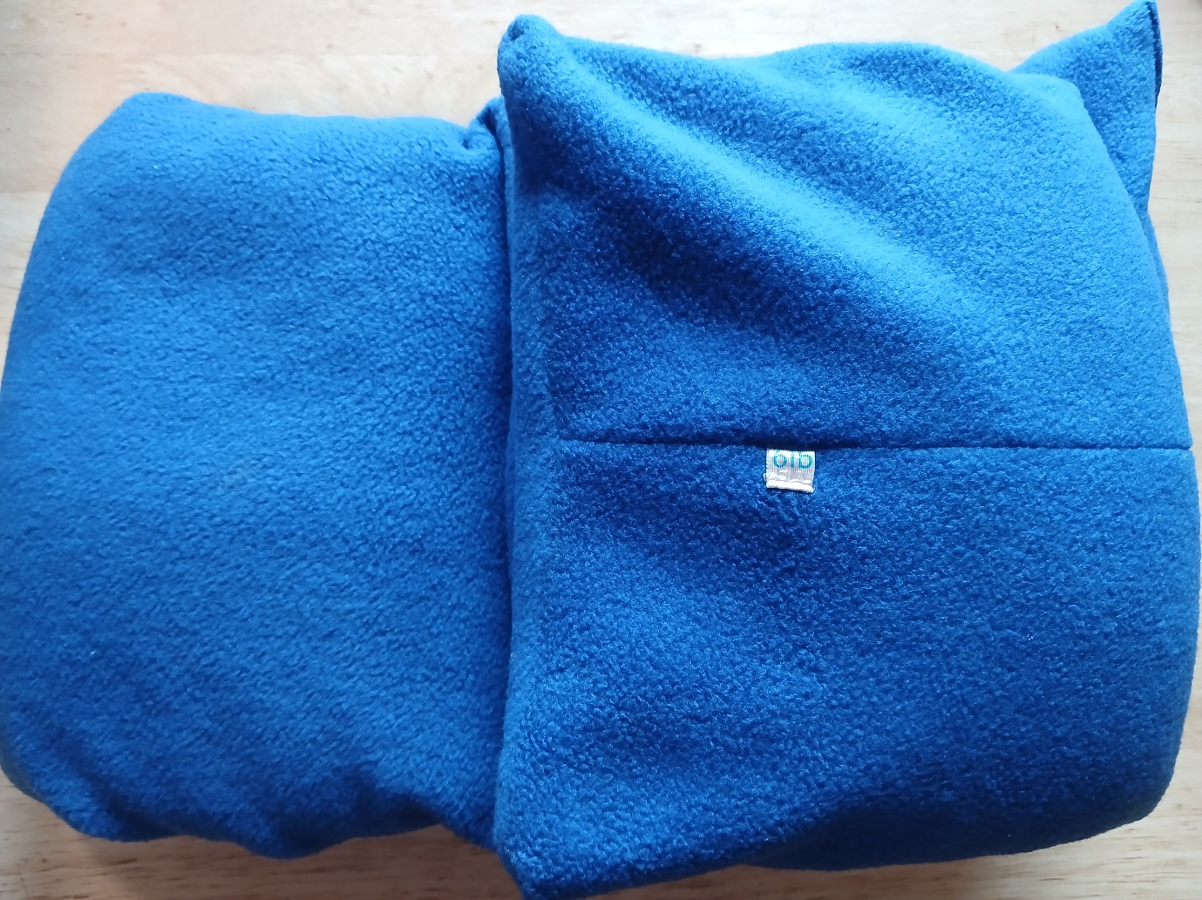
6lb lap - royal blue - 38” x 8.5”

Google review link
Considering getting a google link to have public reviews without showing my address
I do have a few schools who have ordered in the past to contact for reviews

